Keyes Remote Support Instructions

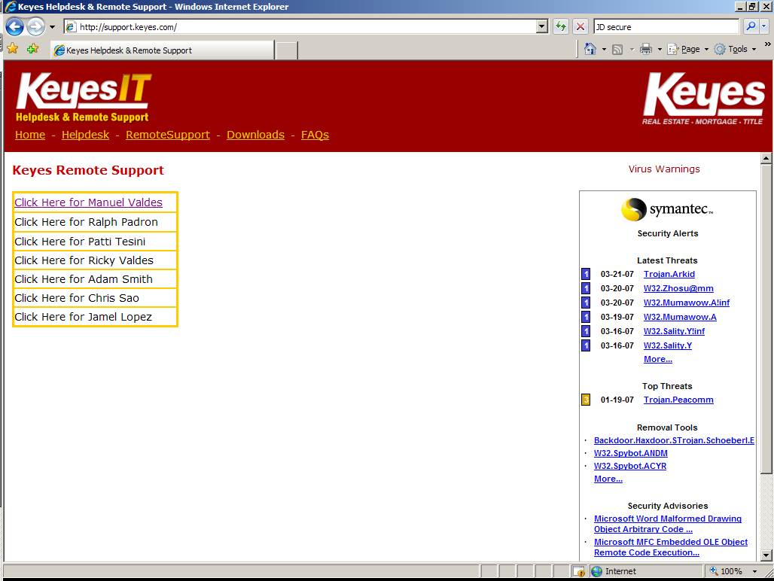

Step 1: Select the person assisting you.

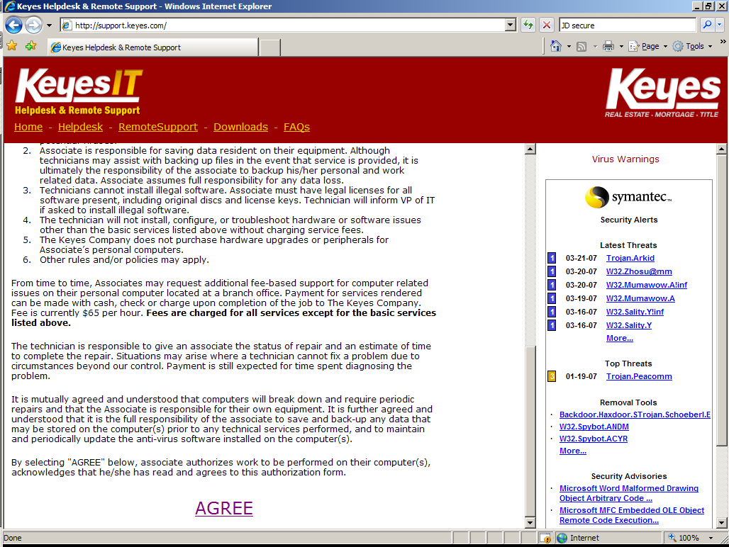

Step 2: Read the Keyes I.T. Service Agreement and Click on “AGREE”
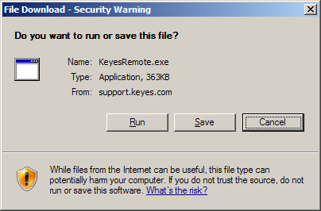

Step 3: Select Run

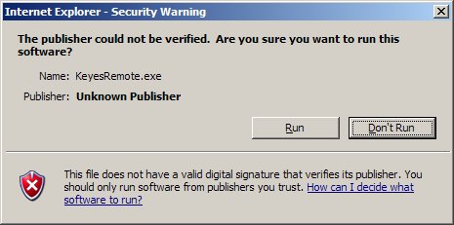

Step 4: Select Run

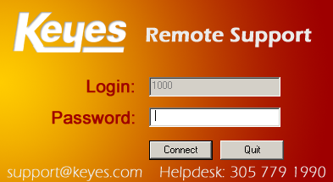

Step 5: Type in the password provided and select Connect.

